Feature Log

Introduction
For this sprint I wanted to ensure that the backend was created properly so that any user could open the application from anywhere and it would still function . The worry was if it was not secure so I went through a few steps to ensure that it was. The frontend had to communicate properly with the database so that users could create or delete their data properly and safely .

Database Creation
The platform is Supabase where authentication is securely controlled.
The schema was non locally created using slq with a primary key uuid to ensure that tables were connected intelligently. The database can now be easily and securely extended to add more complex relationships in the future such as user preferences.
RLS Policies were created to ensure that no other user can affect the other users data.
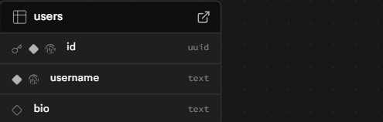

C# Communication with Backend
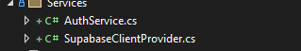
The API was created so that the service files could store such and keep such information encapsulated.
Two service files are implemented to ensure that the API and users are correctly handled into the application .
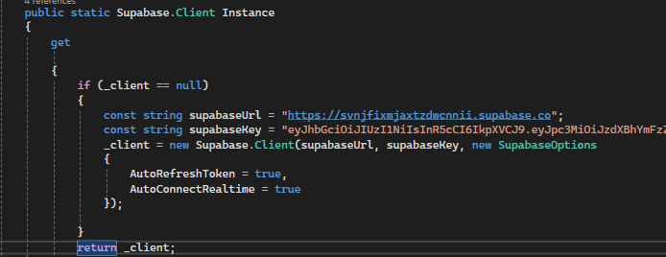
The applications components were properly structured to ensure that functionality displays clearly to the user.
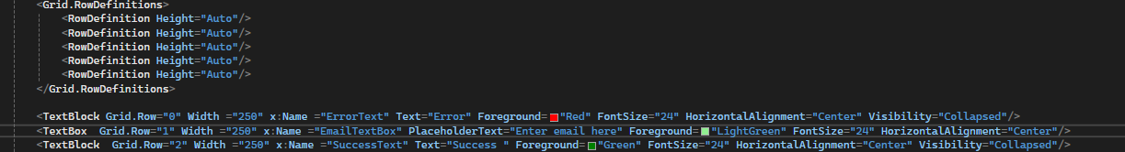

Partial classes were created in order for users to create an account on the frontend and to log in and logout securely properly. The page renders components separately upon a method call using async instead of static methods. The member methods of the service file were implemented in the four new files for user creations to ensure that their account is communicating with the api . The UI shows if they properly did such.
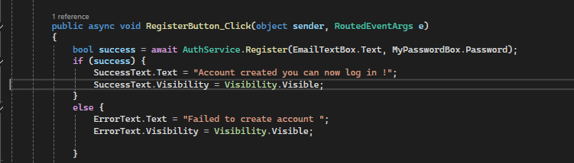

CI CD Pipelines
Azure Devops was connected to the repository to connect to a pipeline.This was to ensure that static analysis can run on the code so that code quality was well . It also sets up for future unit testing .
A dev branch was created to ensure that CI CD practices were properly implemented. Stable versions of the application reside in main whilsts developing versions once verfifed to work can be merged using a pull request.
Branch protection rules were used on the repository to ensure that status checks pass first before merging onto the dev branch .This would make sure that the build success remained up to 80 % .

